# 1: how garfield became handsome

‘Wake up, Garfield from Garfield Kart – Furious Racing.’, said the clumsy, mediocre looking male living organism with a mildly large head.  
‘It’s time to wake up despite you literally being a feline who does not have any responsibilities in life.’  
The funny orange above-average-width feline peeked from his blanket, his eyes only 0.69% opened, as he saw the shoes of his clumsy owner a meter away from him. What goofy individual would wear shoes in the house, what a silly lad! The lasagna-admiring cat did not question this matter, however. He knew that his owner would always wear two different types of socks anyway. Slowly, Garfeidl would close his eyes again, knowing that the chances of it being the first day of the week were quite high.

‘I am not a big fan of the Monday.’, he said to himself. He prepared himself to go back into a state of being unawake, as he had been unasleep for more than 6 seconds, causing him to grow rather drowsy. However, the hit person Jon Arbuckle from The Garfield Show had other ideas. As soon as he witnessed the fat feline going back to sleep, he had to take action immediately. He heroically reached for his pocket, pulling out his Nokia 3310 Classic 113g 22m portable mobile phone device. On the screen he loaded an image of a mischievous, identical looking gray feline (even though the screen of his phone was green like a Gameboy, Jon simply didn’t care), which looked very much like Garf Field himself. However, this was no ordinary feline, as the mere presence of the image material being in a 10km radius of the orange Felis Catus, triggered an intensive neuron activation inside of his brain. Filled with adrenaline, garfeidlssdlf eyes widened, and he jumped into the air, latching towards the portable device that Jonathan Arbuckle was holding into his hand, as if he was identical to the version of himself that was present in the hit videogame ‘Nickelodeon All Star Brawl 2’. Despite this occurrence, Jon quickly managed to avoid Grefiled’s jump, having predicted this event from long ago.  
‘Nuh-uh’, said the now elegant looking male human being towards his pet, proud of his achievement of successfully baiting the attack. Quickly he got rid of the imagery on his phone, the presence of the gray Catus Domesticus no longer being a necessity. Gafrield was now fuming, not very pleased with the action that his owner took.  
 ‘Jonathan Garfbuckle II, I require Italian consumables in order to compromise for the devious activity that you just performed on me.’, garfiefl said.  
Jon, however, brought forward a plate with a single leaf of lettuce, as he said: ‘No garmfield, you know what day it is. It is the very first day of the week, meaning it is time for your diet. And since we both originate from a comic strip released in 1978, the word ‘diet’ is defined by a single leaf of lettuce, as opposed to it being a gradual decrease in number of calories.’. The garfielf then proceeded to facepalm. ‘Blasphemy, simply inconvenient and unbased.’

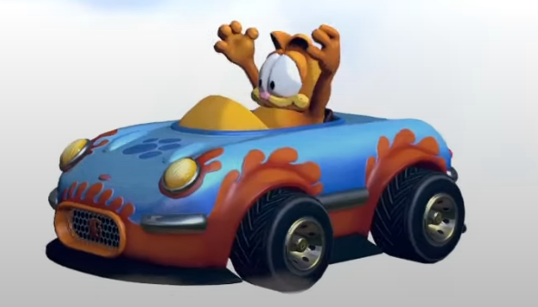After vaporizing the fake food, gardefield then decided to take part in one of his favorite pastime activities. He walked at a moderate pace to make his way to his ScreenON Game PC Extreme Edition – Ryzen 9 7950 – 16TB NVMe SSD – 256 GB RAM – RTX 4090 computer. This computer was crafted specifically for the hit videogame Garfield Kart – Furious Racing, a game in which Garfoiled himself took place. He needs 60 fps after all. After arriving at said computer and starting the game though, he suddenly received a call on the hit communication platform ‘Discord’, causing a mild disturbance in his plan.  
‘This is quite the unfortunate occurrence’, said the field. He decided to ignore the call at first, and picked himself in the videogame, using his signature car, “carfield”, along with it.

However, while he was busy cooking up the NPCs, the right side of the screen suddenly filled up with message spam, causing garfeidols vision to become rather limiting. This was initially no problem for him since he is such an epic gamer, but eventually it did become a slight hinderance. He was not happy with the fact that the right side of based garfeild was covered up with cringe messages. So, after emerging victorious in the race and lapping all the NPCs, he decided to take action in order to get rid of the disturbing force. Nothing may stop the field from garfing after all. He quickly opened the hit app ‘Discord’ and decided to check out which individual was daring to step into his garfing business. However, much to his surprise, there were no messages. He inspected who could have spammed him, but there were no traces left. Only a few DMs from people that he was too lazy to respond to, and those were already a few years old. There was not much time to inspect for much longer however, because the clumsy rizzler Jon Arbuckle was quick to disturb garfoileds inspection. He stumbled into the room, approaching garfieodl the cat.

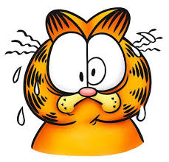‘Garfield from the hit movie Garfield Gets Real.’ said the Jon.  
‘I’m going to get ingredients for lasagen. You better not perform mischievous activities in the household while I’m gone, you silly wide individual. Do not kick Odie into orbit and do not throw Nermal into the trashcan. Speaking of Nermal, I have not witnessed his presence in some time, I wonder where he could be. If I figure out that it was you who lost him, there will be big consequences! Anyway, Jon out, I’m buckling my Ar.’  
Jon Arbuckle then left the room, leaving Garfeidl alone with his computer and his deep thoughts. Jon’s words came and went, his mind too filled with thoughts about the earlier spam during his garfing session to think and listen rationally. He decided to once again try and inspect this matter, but there were still no signs of special messages. This alone made the field relatively uncomfortable. He decided to kart for a little longer, the thoughts remaining inside of his head.